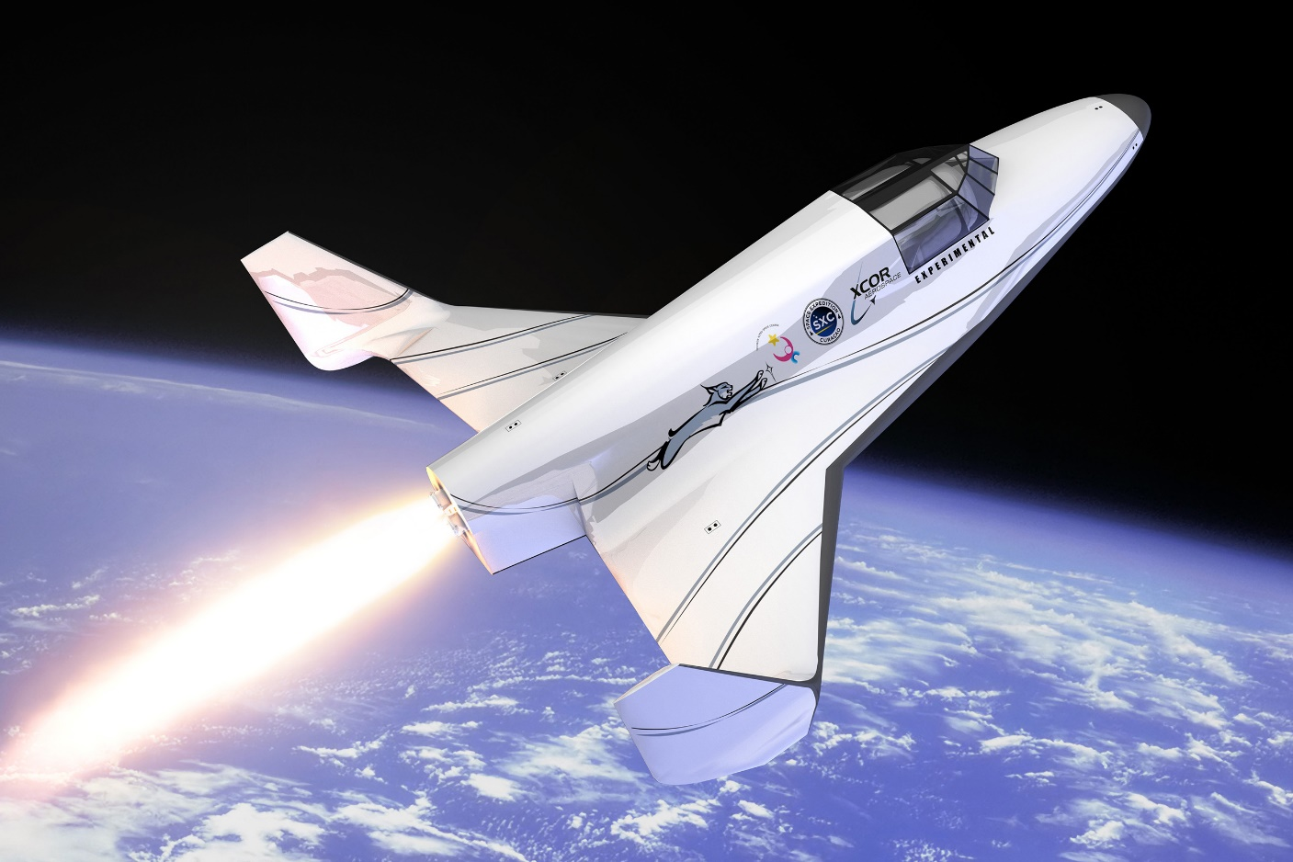**Challenge 1: Maneuverability**

Space Ship in Flight

NASA faces many issues today that seem to be without solution. Astronauts and scientists around the world are faced with many problems regarding transportation. Even the everyday citizen must deal with transportation challenges every now and then. The most common challenge is risking an individual’s safety if a vehicle is designed to have high velocity. That is the sacrifice many people make to gain time. Due to the limited food supply that astronauts have in space, they must be transported at high speeds to reduce the amount of wasted time. However, the safety of these astronauts is at risk if they go out of control and crash. It is not right to put these astronauts’ lives at risk as they are the reason we can learn about what is out there.

How can we transport astronauts without having to put their lives at risk?

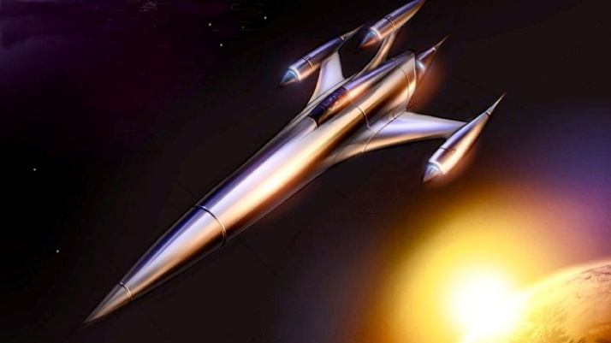Eliminating these safety risks begins with how easily maneuverable a vehicle is at high speed. The vehicle must be easily able to make sharp turns if it is about to collide with an object. This will result in a lower probability of a vehicle colliding with obstacles which will ultimately reduce the chances of an injury. Also, the safety of an individual relies on the reflexes and skills of the conductor of the vehicle. The conductor of the vehicle must be highly experienced and well-trained but this does not ensure the safety of everyone inside of the vehicle. There must be something to reduce the amount of human error, like using machines to guide humans a vehicle while travelling at high speeds.

[2] Space Rocket

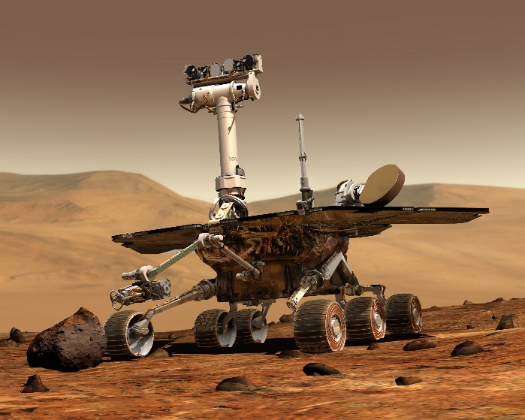

The world is becoming more and more technological everyday. To take advantage of these technological advances, we can put them to test in space.

While travelling at high speeds, we can use technology to detect potential dangers minutes before they happen. This requires us to have high-tech cameras and fast processing computers built into the vehicles. Also, we need to be able to make quick turns to avoid collisions and ensure the safety of all passengers.

[3] Mars Rover

References:

[1]. [Online]. Available: <https://www.rocketstem.org/wp-content/uploads/2014/01/11-07-21_lynx-new-ascent.jpg> [2]. [Online]. Available: [http://i.kinja-img.com/gawker-media/image/upload/s--dBKATTgX--/18655zklmlyodjpg.jpg [3](http://i.kinja-img.com/gawker-media/image/upload/s--dBKATTgX--/18655zklmlyodjpg.jpg%20%20%5b3)]. [Online]. Available: https://upload.wikimedia.org/wikipedia/commons/d/d8/NASA_Mars_Rover.jpg

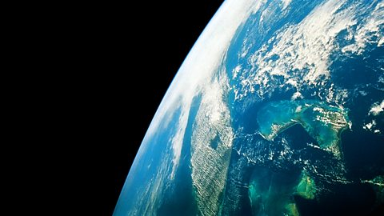**Challenge 2: Living Outside**

[4] Planet Earth

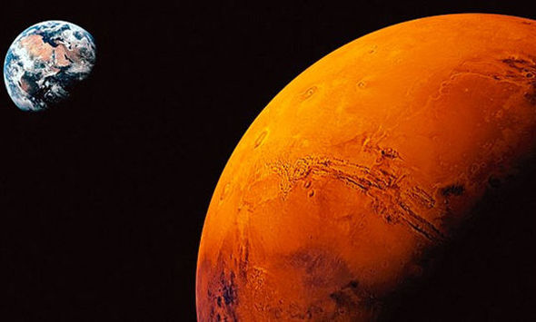NASA faces many difficult challenges today. One of which is living on a planet that is not ours. The simplest planet to have life on would be Mars. This is due to the many characteristics that Mars shares with Planet Earth. However, without an atmosphere to shield us from any meteorites, or deadly rays from the sun, we cannot do much. The dream of living on another planet does have its flaws, but hopefully there will be a day where that dream becomes its own reality.

[5] Mars and Earth

Can we allow astronauts to safely live in outer space?

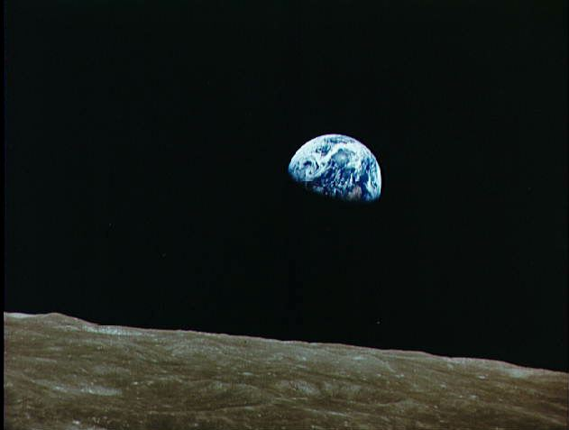

Many problems can occur in outer space and one of them is the extreme conditions of temperature. [6] Being in outer space, temperatures can decrease to -270.45 degrees Celsius. At these conditions, it is almost impossible to live comfortably.

[7] View of Earth of the Moon

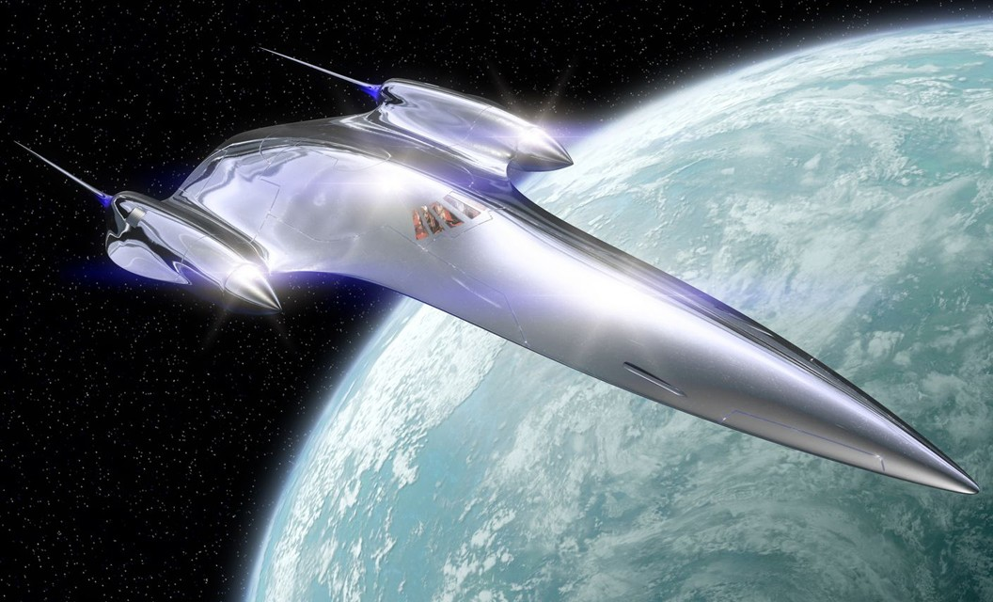We must design a comfortable space craft to keep all passengers warm and comfortable. It must be easily able to heat to high temperatures and insulate the heat so it does not escape. The space craft will be able to reflect coldness to maintain the temperature inside the space craft.

[8] Reflecting Space Shuttle

References:

[4]. [Online]. Available: <https://ichef.bbci.co.uk/images/ic/480x270/p01l49tk.jpg> [5]"Mars-Earth,". [Online]. Available: <http://cdn.images.express.co.uk/img/dynamic/151/590x/secondary/Mars-Earth-355005.jpg> [6]F. Cain, "How cold is space?," in *Guide to Space*, Universe Today, 2013. [Online]. Available: http://www.universetoday.com/77070/how-cold-is-space/. [7]. [Online]. Available: <http://en.es-static.us/upl/2001/07/apollo_8_earthrise.jpeg> [8]. [Online]. Available: https://echostation57.files.wordpress.com/2011/02/naboo-cruiser-1.jpg

**Challenge 3: Food and Water**

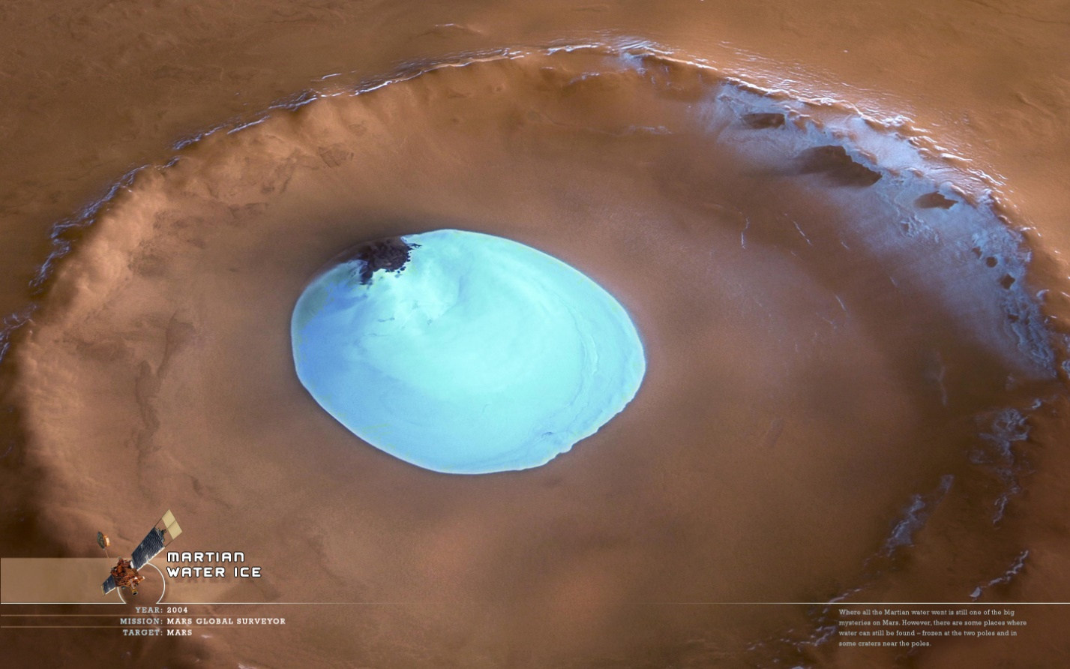Food and water is essential to human life. Without either of the two, we would not exist.

[9] Mars Water

The challenge is how can we allow the largest amount of water and food supply in space?

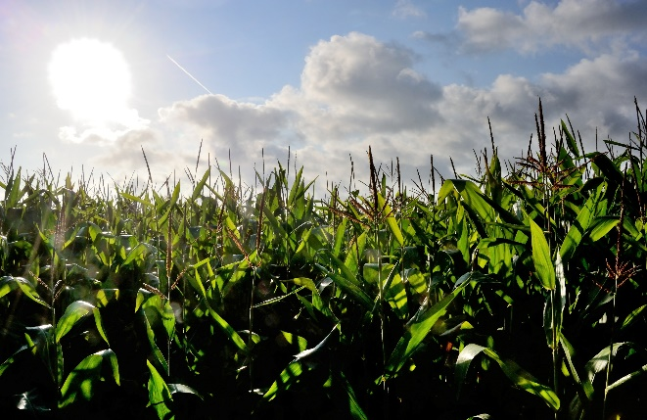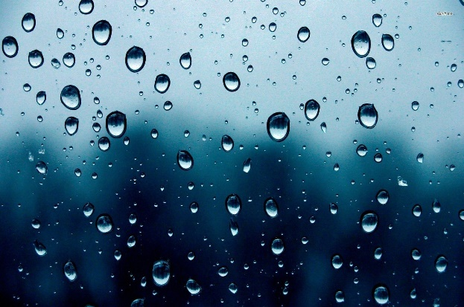Due to the high-water supply on Earth, it is not difficult for us to retain a water supply. However, when travelling in space, there is a limited water supply when considering the amount of weight that water will take up as well as the number of passengers in the space shuttle needing to drink water at least once every three days. Having a higher water supply will result in an extended amount of time used to travel, because it will slow the velocity of the spacecraft due to the extra weight of water being added on. This is especially the problem when there are multiple passengers, who need enough water to survive for at least 39 days until they reach their destination. Once the destination is reached, a water supply must be somehow retained without the help of the many oceans that we have here on Planet Earth.

[11] Farming and Crops

Food supply is also a big aspect in space travelling. It would not be beneficial to feed anyone the same food everyday. The astronauts must be on a well-balanced diet as they must always be fully functioning. The constraints of food are that, similarly to water, food will weigh down the space craft. Food and water will increase the overall

[10] Rain Drops

weight of the spacecraft, which will have a great impact on its velocity.

We must find a way to grow crops while inside of the spacecraft. This way, the astronauts do not have to worry about weighing anything down with a large food supply. Growing crops will allow them to make as much food as they need for the time being and continuously grow food to survive the next day. This also takes away the troublesome of calculating the amount food needed to reach the destination as growing crops will give them an unlimited supply of food.

To ensure the safety of space travelling, astronauts need to be certain that they will have enough food to survive their mission.

References:

[9]. [Online]. Available: http://natureworldreport.com/wp-content/uploads/mars-water.jpg [10]. [Online]. Available: <http://wallpapercave.com/wp/Qb2bUq0.jpg>.[11]. [Online]. Available: https://cbsminnesota.files.wordpress.com/2013/07/150604747.jpg.

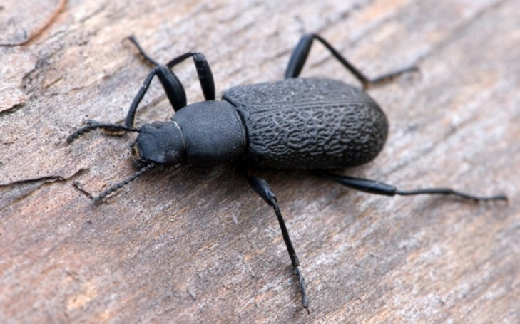**Organism 1: Alaskan Darkling Beetle**

**Function:** Protect from extremely cold weather

**Scientific Name:** Upis ceramboides

**Biological Strategy:**

Although this little beetle might look small and pathetic at first, it has a couple of tricks underneath its shell. To protect itself from extremely cold weathers, the beetle produces its own sugar-based antifreeze contents behind its shell. This content is called xylomannan, which is a polymer of alternating xylose and mannose sugars. It keeps the liquid substances inside of the beetle from freezing from the cold weather of Alaska. It is said that this beetle can survive from exposure to up to minus 100 degrees Celsius.

[12] Alaskan Darkling Beetle(Upis Ceramboides)

**Mechanism:**

Xylomannan sticks to the outer shell, which prevents ice from getting in. This keeps ice from forming inside of whatever is inside of the shell.

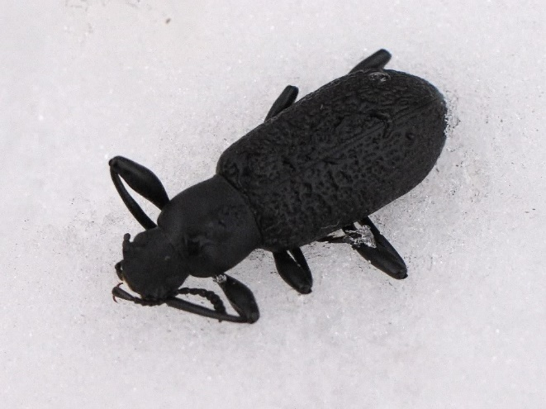

[13] Alaskan darkling beetle in winter conditions

**Design Principle:**

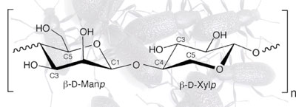

[14] Polymer of Xylomannan

**Application Idea:**

* Locate in between walls of a spaceship
* Apply onto space suits to prevent freezing

**Key Life Principles:**

* Cannot weigh down suit/spaceship
* Acts as shield from ice and extreme cold weathers

References:

[12]